Adapter Design Pattern
- The Adapter Design Pattern is a structural pattern that allows objects with incompatible interfaces to work together. It acts as a bridge between two incompatible interfaces.
- This pattern is useful when you want to use existing classes, but their interfaces do not match the one you need.
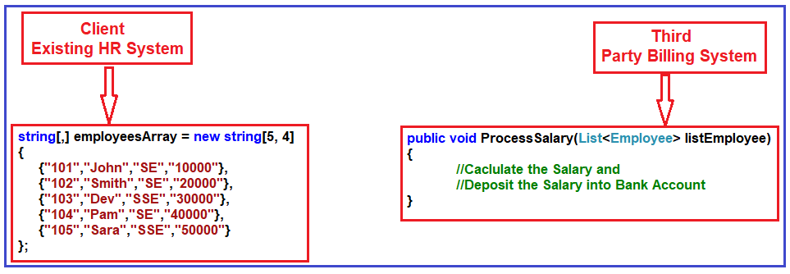
How can we make these two incompatible systems work together?
We need to introduce an Adapter between the HR and Third Party Billing systems, as shown in the image below.
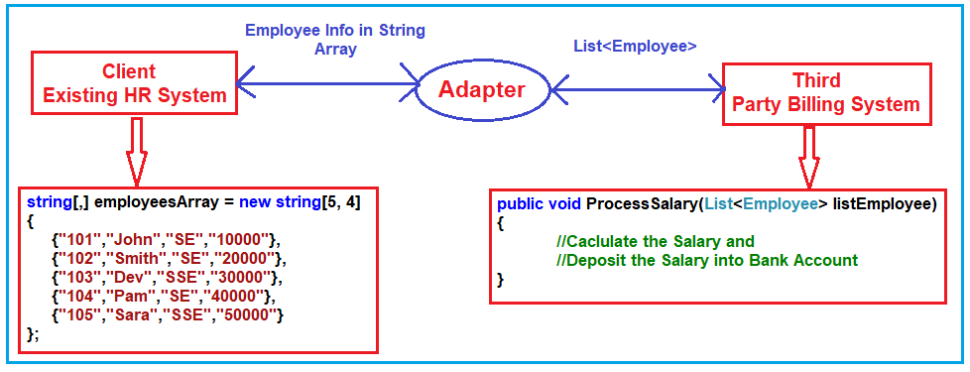
Adapter Design Pattern in C# can be implemented in two ways.
- Object Adapter Pattern
- Class Adapter Pattern

Implementation of Object Adapter Design Pattern in C#:

Step 1: Creating Employee Class

Step2: Creating Adaptee

Step3: Creating ITarget interface

Step4: Create an Adapter

Step5: Client

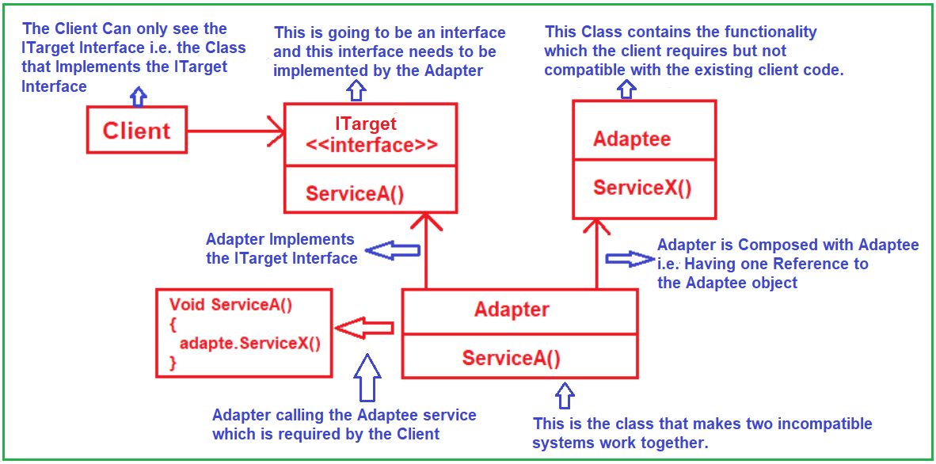

Class Adapter Design Pattern in C#:

This is another approach to implementing the Adapter Design Pattern in C#. In this approach, the Adapter calls will implement the ITarget interface and inherit from the Adaptee class. That means the Adapter class will now be a child of the Adaptee class. So, instead of creating a reference variable of Adaptee to call the Adaptee method, it can call that method directly as it is available via inheritance. Before implementing the same example using the Class Adapter Design Pattern, let us first understand the class diagram of the Class Adapter Design Pattern. Please have a look at the following image.

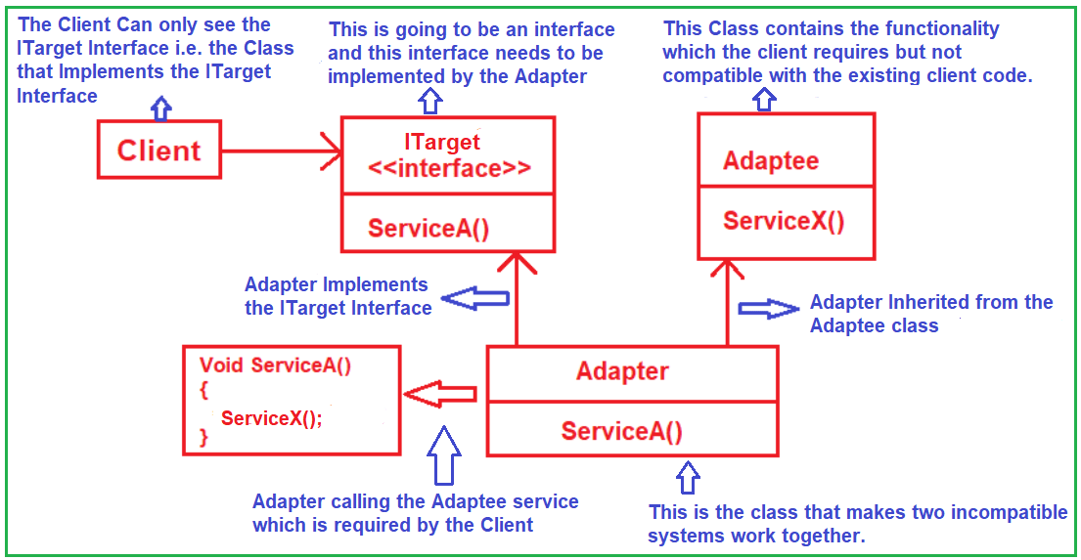

Facade Design Pattern in C#?
Facade Design Pattern states that you need to provide a unified interface to a set of interfaces in a subsystem. The Facade Design Pattern defines a higher-level interface that makes the subsystem easier to use.
The Facade Design Pattern is a structural pattern that provides a simplified interface to a complex system of classes, libraries, or frameworks. The primary goal of the Facade pattern is to present a clear, simplified, and minimized interface to the external clients while delegating all the complex underlying operations to the appropriate classes within the system. The Facade (usually a wrapper) class sits on the top of a group of subsystems and allows them to communicate in a unified manner.
As the name suggests, Facade means the Face of the Building. Suppose you created one building. The people walking outside the building can only see the walls and glass of the Building. The People do not know anything about the wiring, the pipes, the interiors, and other complexities inside the building. That means the Facade hides all the complexities of the building and displays a friendly face to people walking outside the building.

Understanding Facade Design Pattern in C# with one Real-Time Example:
- Identify Complex Subsystems: First, identify the complex parts of your system that need simplification. These could be complex libraries or systems with multiple interacting classes.
- Create a Facade Class: Design a facade class that provides a simple interface to the complex subsystems.
- Delegate Calls to Subsystems: The facade should delegate the client requests to the appropriate objects within the subsystem. The facade should handle all the intricacies and dependencies of the subsystems.
- Client Code Interaction: The client interacts with the system through the facade, simplifying its use of the complex subsystems.
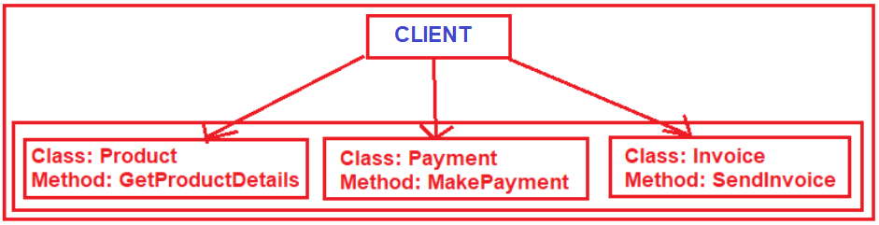
As shown in the above image, to place an order first, the Client needs to create an object of the Product class and get the product details by calling the GetProductDetails method. Then, if everything is fine (i.e. if the Product is available in stock), you need to make the Payment. To do this, the Client needs to create an instance of the Payment class and need to call the MakePayment method. If Payment is successful, then we need to send the Invoice to the customer and to do so, the Client needs to create an instance of the Invoice class and call the SendInvoice method. So, to place the order, the Client needs to do the above-mentioned steps in a particular order.
The Facade Design Pattern in C# is actually an extra class (i.e., a Wrapper class or, you can say, Facade Class) that sits at the top of the above classes. Please have a look at the following diagram for a better understanding.
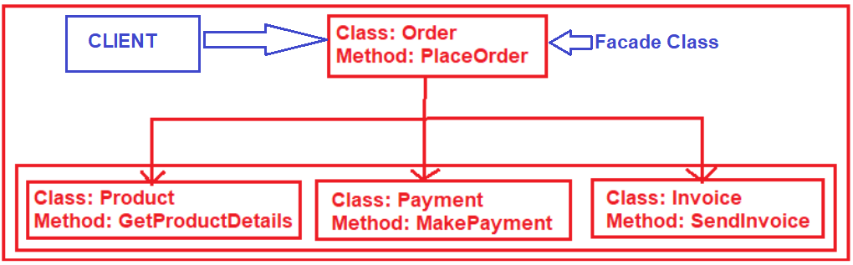
So, here, the extra class Order is nothing but the Facade class, which will be responsible for placing the order. This class internally creates the instance of the respective classes and calls the methods in a particular order. Now, the Client will not call the respective classes and their methods to place the order; instead, the Client will call the Order Class, PlaceOrder to method to place an order. The PlaceOrder method will internally use the Product, Payment, and Invoice classes to place the order.
Note: The point that you need to remember is the Facade Design Pattern not only decreases the overall complexity of the application but also helps to move the unwanted dependencies to one place. Facade deals with interfaces, not implementation. The actual implementation is going to be provided by the Subsystems.
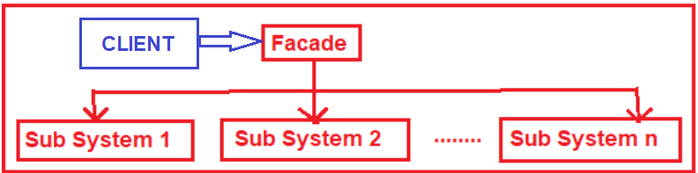

As shown in the above image, three classes are involved in the Facade Design Pattern. They are as follows:
- The Facade Class knows which subsystem classes are responsible for a given request, and then it delegates the client requests to appropriate subsystem objects.
- The Subsystem Classes implement their respective functionalities assigned to them, and these Subsystem Classes do not know the Facade class.
- The Client Class uses the Façade Class to access the subsystems.

Implementing Facade Design Pattern in C#:

Step 1: Creating Subsystems

Product Subsystem:

Payment Subsystem:

Invoice Subsystem:

Step 2: Creating the Facade Class

Step 3: Client

Advantages of Facade Design Pattern:
- Simplified Interface: Offers a single, simplified interface to the complex subsystems, making the subsystems easier to use.
- Reduced Complexity: Clients interact with a single unified interface rather than directly with the complex subsystems, reducing the system’s perceived complexity.
- Isolation: Provides a degree of isolation from the complex subsystems, which can be beneficial when there are frequent subsystem changes.
- Improved Testability and Maintainability: Facade can simplify the testing process by limiting the interdependencies and focusing on system interfaces.

When to use Facade Design Patterns in Real-Time Applications?

The Facade Design Pattern is particularly beneficial in the following scenarios:

- Simplifying Complex Systems: When dealing with a complex system or framework with multiple interdependent classes or layers, you want to provide a simple interface to these systems. The Facade pattern can encapsulate this complexity behind a simple, unified interface.
- Decoupling Systems: If you want to decouple a system where the components are tightly coupled or interdependent, a facade can provide loose coupling by not exposing the internal complexities to the client.
- Layered Architecture: A facade can act as an entry point to each layer in multi-layered architecture. This is particularly useful in large applications or systems where each layer has complexities.
- Improved Readability and Usability: When you aim to improve the readability and usability of a system. A facade can provide a clear and straightforward way to interact with a complex subsystem, making it easier for other developers to understand and use it.
- Reducing Dependencies: To reduce external code dependencies on the inner workings of a library or framework, thereby shielding the client code from future changes or complexities in the subsystem.
- Subsystem Interface Standardization: For standardizing the interfaces of subsystems. If different subsystems have different interfaces, a facade can provide a uniform interface to all these subsystems, making them easier to work with.

Example without using Facade Design Pattern in C#:
Let us first implement the Customer Registration Application without following the Facade Design Pattern. In this example, we are going to use the Customer class to store the customer data along with one class called Validator to validate the customer data, one class called CustomerDataAccessLayer to save the customer data in the database, and one class called Email to send the successful registration email to the customer.
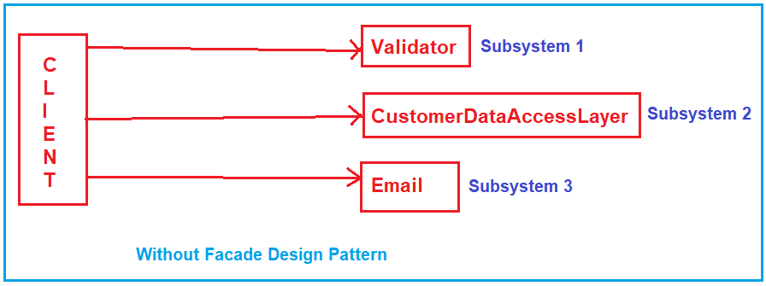

Using the above Classes in Client Code:
Now, we need to use the above classes in the client to provide the customer registration functionality. The Client should and must use the above classes and methods in the following order.
- First, create an instance of the Customer class, then populate the properties with the required data
- Next, we need to create an instance of the Validator class and need to call the ValidateCustomer method by passing the customer object to validate the customer data.
- Once the customer is validated, then the client should create an instance of the CustomerDataAccessLayer class and must call the SaveCustomer method to save the data into the database.
- Once the data is saved successfully in the database, then the client needs to create an instance of the Email class and needs to call the SendRegistrationEmail method to send the registration successful confirmation email to the customer.

What is the Problem with the above Design?
Now, if you see the output, then you will see the output as expected. Then what is the problem with the above application design?
The problem is now we have many subsystems like Validator, CustomerDataAccessLayer, and Email.
And the Client needs to follow the appropriate sequence to create and consume the objects of the above subsystems.
And here, there is a high chance that the client might not follow the proper sequence, or the client might forget to use one of the subsystems. For example, in the below code, the client forgot to use the Validator class and hence there is a chance that we might save some invalid data in the database.

How we can overcome these problems?
Instead of providing access to these subsystems, if we create a simple interface and give access to the client and the client will use the simple interface to do the registration. The complex logic will be written inside the simple interface. And we can achieve this very easily by using the Facade Design Pattern in C#.
The Facade Design Pattern will hide all the complexity and provide an easy-to-use interface to the client and the client will use the Facade instead of the subsystems. So, with Facade Design Pattern, our class diagram or UML diagram will look like the one below.
